Screen Captures of Module 2 Challenge Results

2018 Worksheet Results:

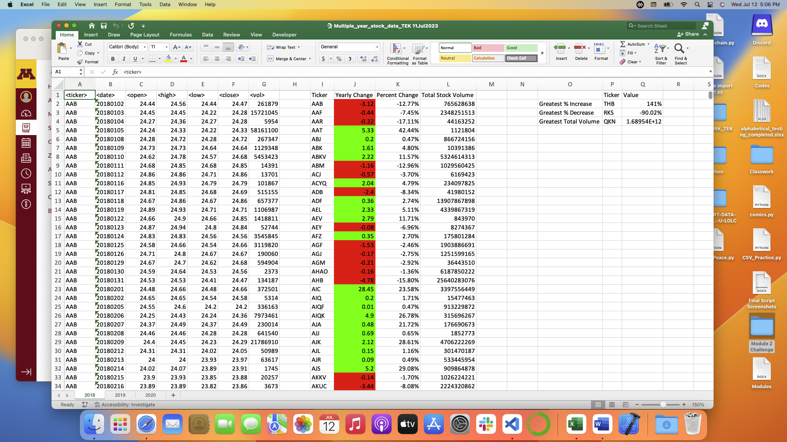

2019 Worksheet Results:

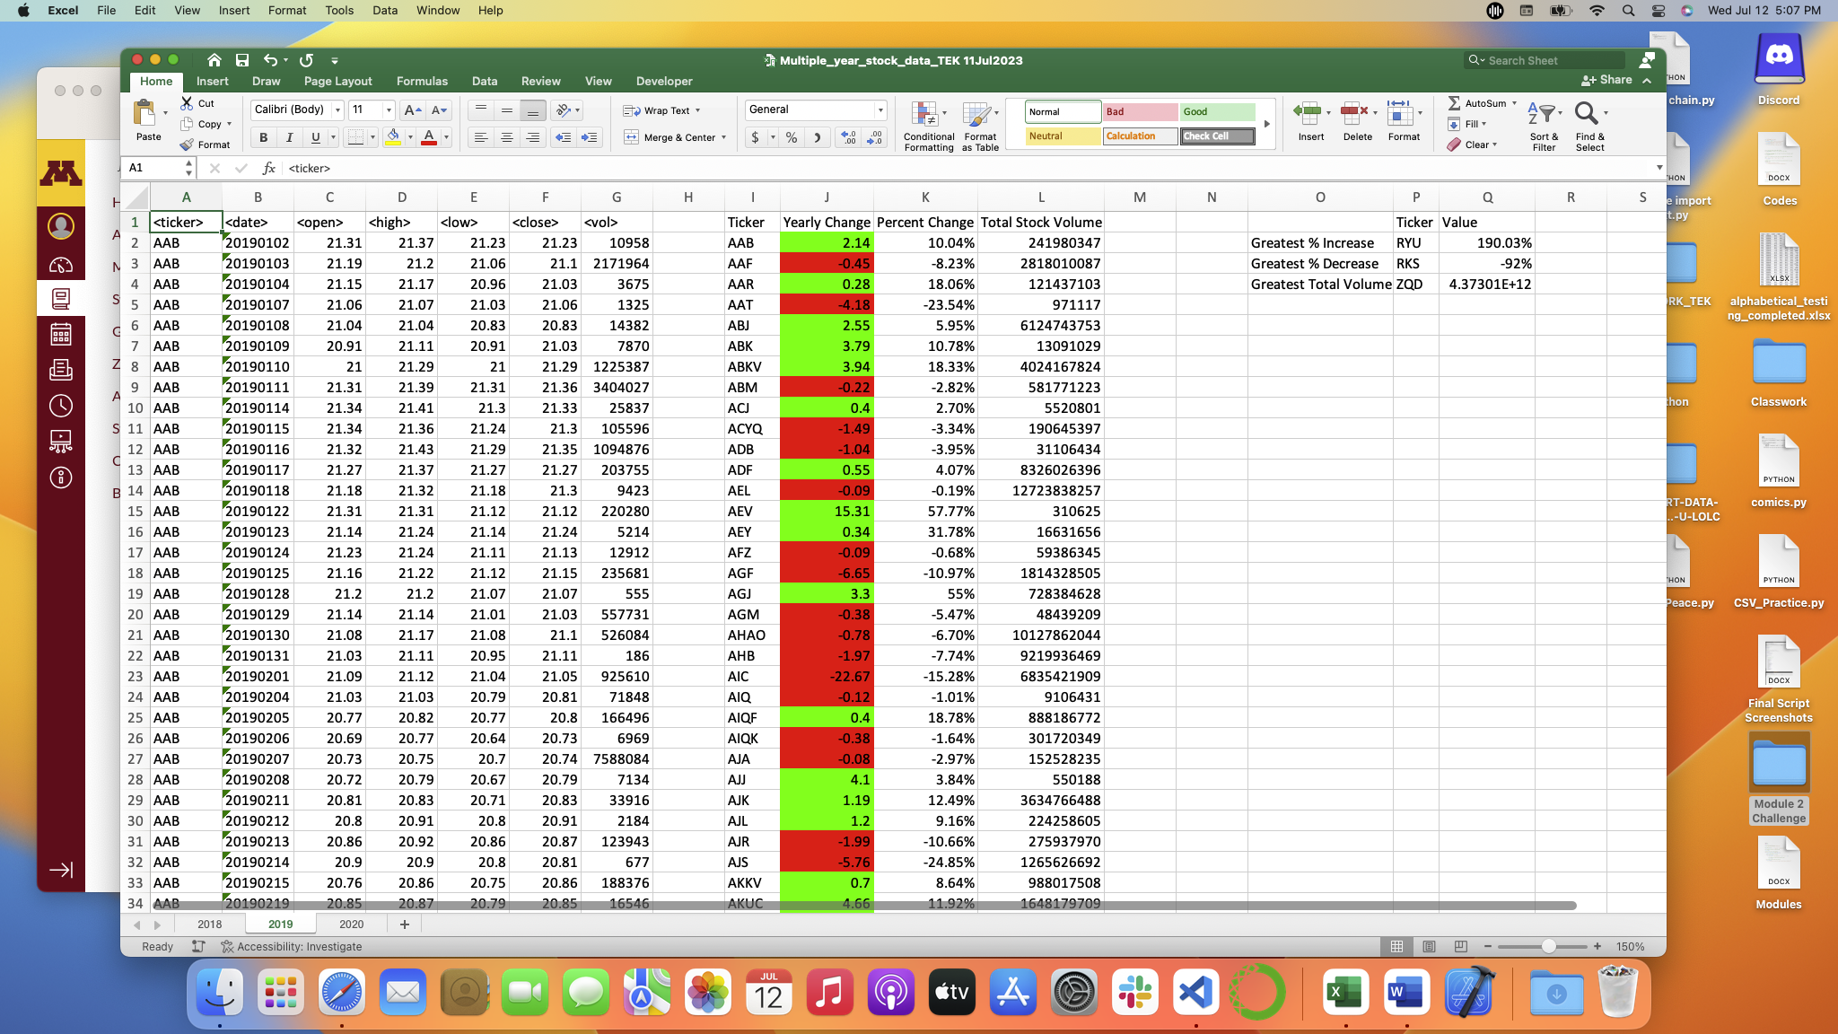

2020 Worksheet Results:

